

|  |
| --- |
|  |





|  |
| --- |
| c.wmf |



|  |
| --- |
| e.wmfeu.wmf |



|  |
| --- |
| f.wmf |



|  |
| --- |
| ill.wmf |



|  |
| --- |
| in.wmf |







|  |
| --- |
| j.wmf |





|  |
| --- |
| o.wmf |



|  |
| --- |
| on.wmf |





|  |
| --- |
| post-it-c g.jpgs.wmf |

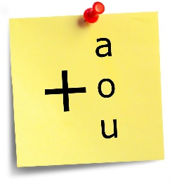



|  |
| --- |
| z.wmf |

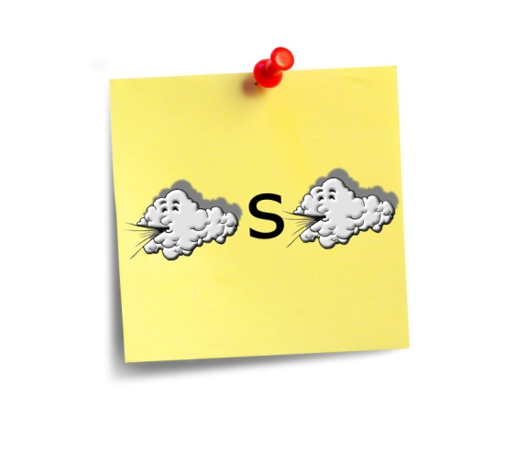



|  |
| --- |
| 0 |



|  |
| --- |
|  |