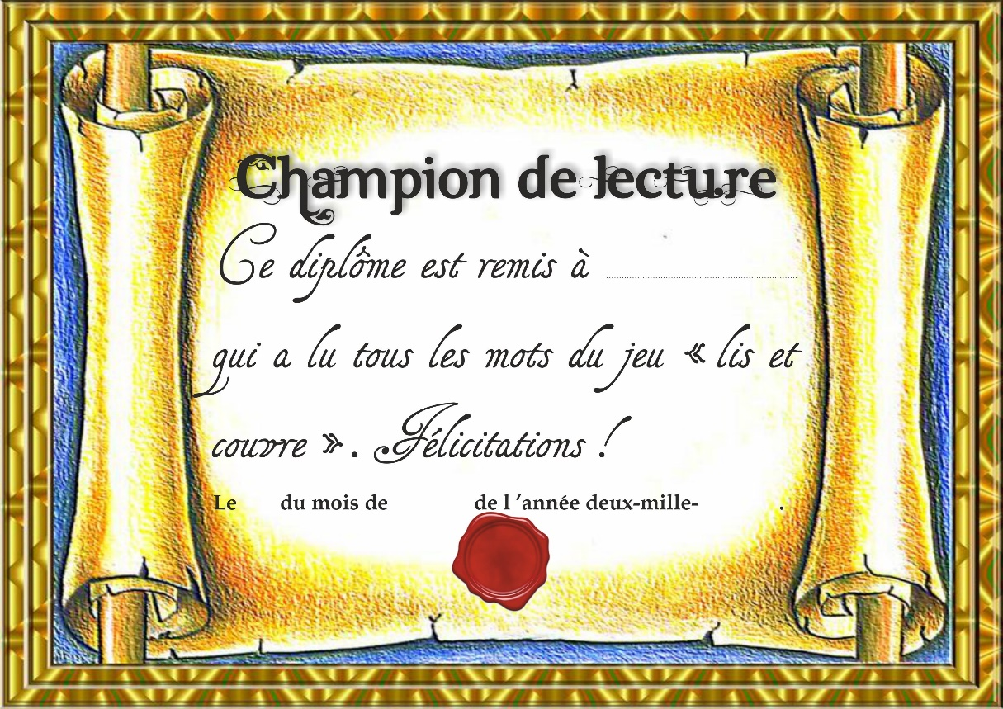

Niveau 1

|  |  |  |  |  |
| --- | --- | --- | --- | --- |
| ● | ● | ● | ● | ● |
|  |  |  |  |  |

Niveau 2

|  |  |  |  |  |  |  |  |
| --- | --- | --- | --- | --- | --- | --- | --- |
| ● | ● | ● | ● | ☺ | ☺ | ☺ | ☺ |
|  |  |  |  |  |  |  |  |

Niveau 1

|  |  |  |  |  |
| --- | --- | --- | --- | --- |
| ● | ● | ● | ● | ● |
|  |  |  |  |  |

Niveau 2

|  |  |  |  |  |  |  |  |
| --- | --- | --- | --- | --- | --- | --- | --- |
| ● | ● | ● | ● | ☺ | ☺ | ☺ | ☺ |
|  |  |  |  |  |  |  |  |