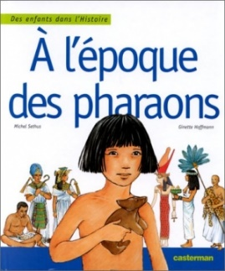
Lecture-discrimination visuelle
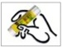

Colle les lettres pour écrire le mot.

S | é | t | h | i

f | ê | t | e

1

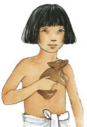

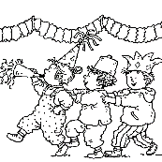

---------------------------------------------------------------------------------------------------------------------
S | l | h | i | c | d | t | e
é | k | t | a | b | f | ê | g

Lecture-discrimination visuelle

Colle les lettres pour écrire le mot.

école

retard

1

---------------------------------------------------------------------------------------------------------------------
é | l | e | q | h | i | j | b
c | o | r | e | t | a | r | d

Lecture-discrimination visuelle

Colle les lettres pour écrire le mot.

S | é | t | h | i

v | i | l | l | e

2

---------------------------------------------------------------------------------------------------------------------
e | b | S | m | n | v | i | o
u | k | é | t | h | i | l | l

Lecture-discrimination visuelle

Colle les lettres pour écrire le mot.

marche

vieux

2

---------------------------------------------------------------------------------------------------------------------
p | a | r | q | v | i | x | s
m |  | c | h | e | e | u | t

Lecture-discrimination visuelle

Colle les lettres pour écrire le mot.

m | a | î | t | r | e

l | e | ç | o | n

3

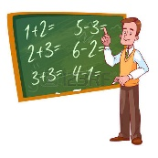

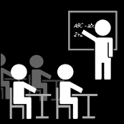

---------------------------------------------------------------------------------------------------------------------
u | m | t | w | r | e | ç | o
n | a | î | v | x | l | e | y

Lecture-discrimination visuelle

Colle les lettres pour écrire le mot.

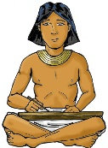 scribe

calcul

3

---------------------------------------------------------------------------------------------------------------------
z | l | a | r | i | b | e | c
s | c | b | c | u | l | d | a

Lecture-discrimination visuelle

Colle les lettres pour écrire le mot.

t | e | m | p | l | e

p | e | n | s | e

4

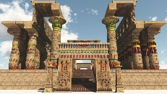

---------------------------------------------------------------------------------------------------------------------
f | t | h | l | e | n | s | e
g | e | m | p | p | e | i | j

Lecture-discrimination visuelle

Colle les lettres pour écrire le mot.

suivre

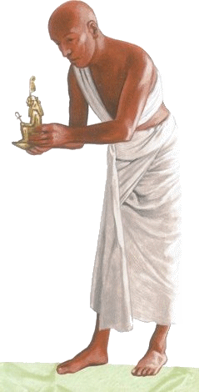 prêtre

4

---------------------------------------------------------------------------------------------------------------------
s | e | r | r | k | n | p | ê
u | i | v | e | l | m | r | t

Lecture-discrimination visuelle

Colle les lettres pour écrire le mot.

b | a | t | e | a | u

m | a | r | c | h | e

5

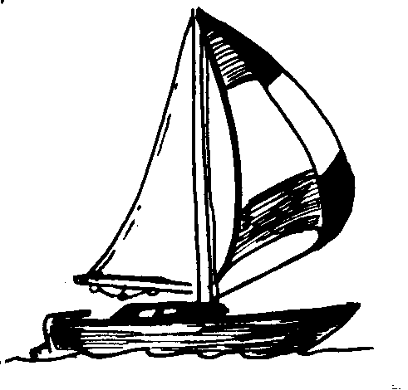

---------------------------------------------------------------------------------------------------------------------
o | b | e | p | q | m | a | r
h | a | t | e | a | u | s | c

Lecture-discrimination visuelle

Colle les lettres pour écrire le mot.

voir

Nil

5

---------------------------------------------------------------------------------------------------------------------
t | a | r | N | b | c | x | y
v | o | i | i | l | u | w | z

Lecture-discrimination visuelle

Colle les lettres pour écrire le mot.

a | r | r | i | v | e

p | è | r | e

6

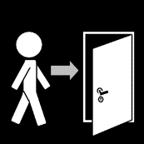

---------------------------------------------------------------------------------------------------------------------
d | r | v | e | p | h | r | e
a | r | i | f | g | è | i | j

Lecture-discrimination visuelle

Colle les lettres pour écrire le mot.

fête

rencontre

6

---------------------------------------------------------------------------------------------------------------------
k | t | l | r | c | o | n | e
f | ê | m | e | n | e | t | r

