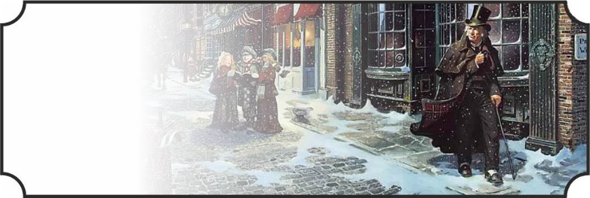  

Scrooge dort.

Scrooge voyage.

Scrooge voyage.

  

Scrooge dort.

Scrooge voyage.

Scrooge voyage.

  

Scrooge dort.

Scrooge voyage.

Scrooge voyage.

  

Scrooge dort.

Scrooge voyage.

Scrooge voyage.

  

Scrooge dort.

Scrooge voyage.

Scrooge voyage.

  

Scrooge dort.

Scrooge voyage.

Scrooge voyage.

  

Scrooge dort.

Scrooge dort.

Scrooge voyage.

  

Scrooge dort.

Scrooge dort.

Scrooge voyage.

  

Scrooge dort.

Scrooge voyage.

Scrooge dort.

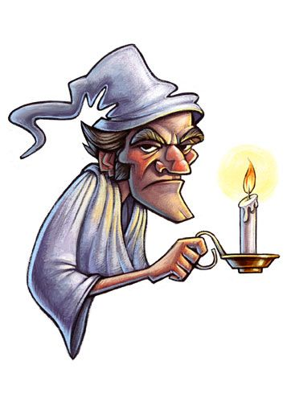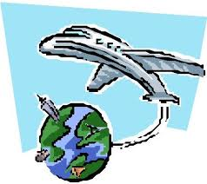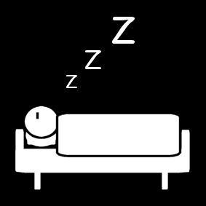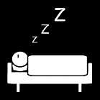 

voyage

dort

dort

dort

dort

|  |  |  |
| --- | --- | --- |
| Scrooge | voyage. | dort. |



|  |  |  |  |  |  |  |
| --- | --- | --- | --- | --- | --- | --- |
| départ |  |  |  |  |  |  |

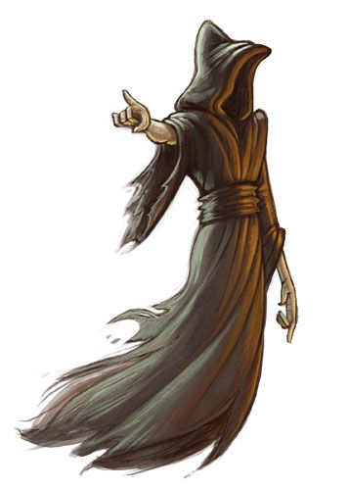

|  |  |  |  |  |  |  |
| --- | --- | --- | --- | --- | --- | --- |
|  |  |  |  |  |  | arrivée |

|  |  |  |  |  |  |  |
| --- | --- | --- | --- | --- | --- | --- |
| départ |  |  |  |  |  |  |



|  |  |  |  |  |  |  |
| --- | --- | --- | --- | --- | --- | --- |
|  |  |  |  |  |  | arrivée |