Blanche-Neige

Arrow 1.png

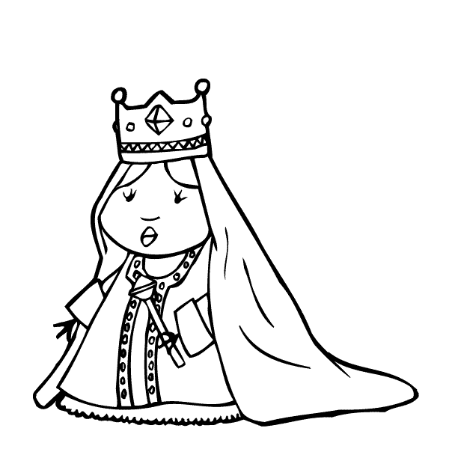

Arrow 1.png



Arrow 1.png

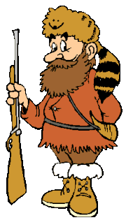

Arrow 1.png

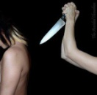

Arrow 1.png

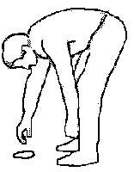

|  |  |  |  |  |
| --- | --- | --- | --- | --- |
| reine | méchante | chasseur | tue | trouve |
| chasseur | reine | tue | méchante | trouve |

Blanche-Neige

Arrow 1.png

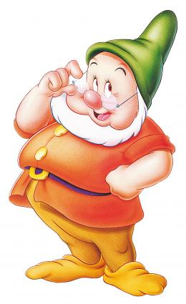

Arrow 1.png

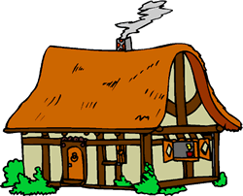

Arrow 1.png



Arrow 1.png

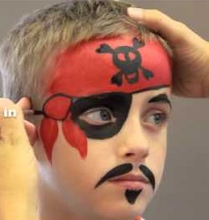

Arrow 1.png



|  |  |  |  |  |
| --- | --- | --- | --- | --- |
| nain | maison | colère | maquille | reine |
| reine | colère | maquille | nain | maison |

Blanche-Neige

Arrow 1.png

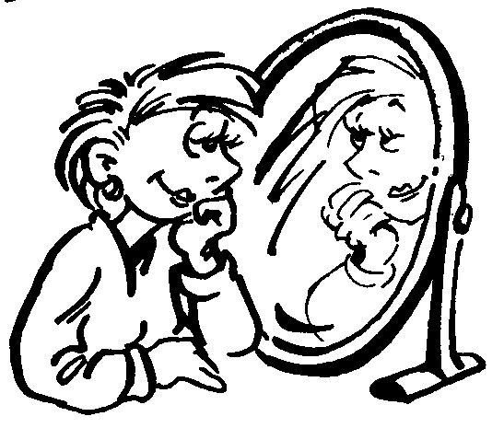

Arrow 1.png



Arrow 1.png

POISON.BMP

Arrow 1.png

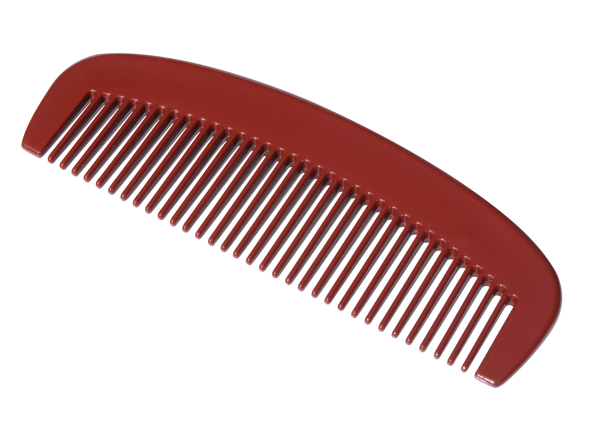

Arrow 1.png



|  |  |  |  |  |
| --- | --- | --- | --- | --- |
| miroir | verse | poison | peigne | nain |
| peigne | nain | poison | verse | miroir |

Blanche-Neige

Arrow 1.png

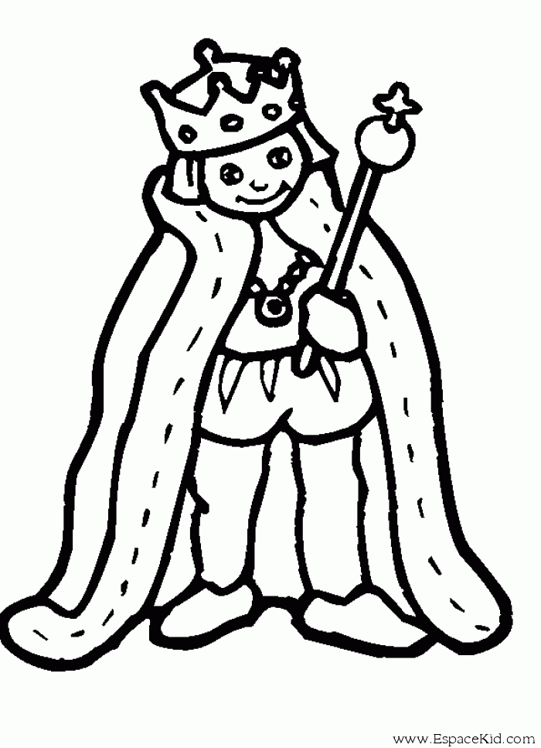

Arrow 1.png



Arrow 1.png

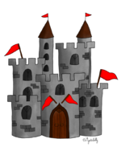

Arrow 1.png

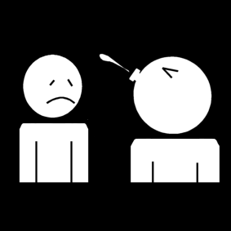

Arrow 1.png



|  |  |  |  |  |
| --- | --- | --- | --- | --- |
| prince | trouve | château | crache | marient |
| crache | prince | marient | château | trouve |