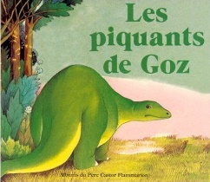
Lecture - discrimination visuelle
1
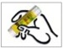
Colle les mots à la bonne place en t'aidant de ton texte.

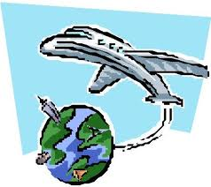

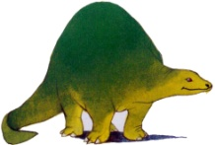

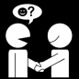

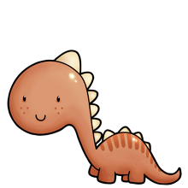

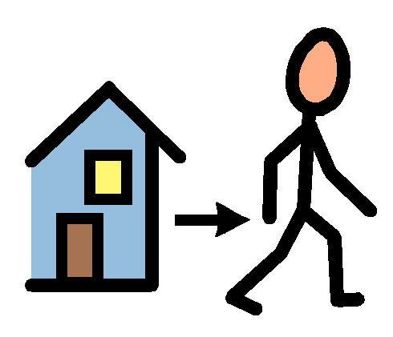

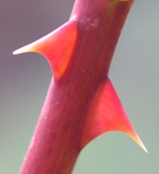

---------------------------------------------------------------------------------------------------
Goz | rencontrent
piquants | partent
dinosaures | voyage

Lecture - discrimination visuelle
2
Colle les mots à la bonne place en t'aidant de ton texte.

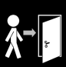

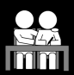

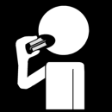

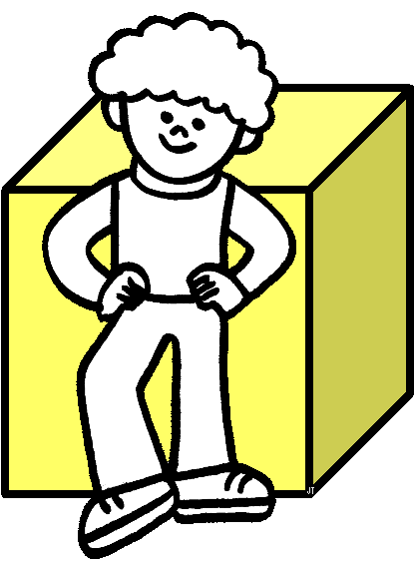

---------------------------------------------------------------------------------------------------
dinosaure | rencontrent
devant | arrivent
aide | mange

Lecture - discrimination visuelle
3
Colle les mots à la bonne place en t'aidant de ton texte.

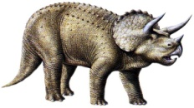

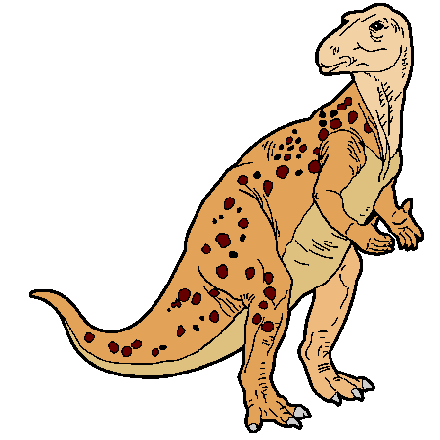

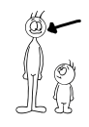

---------------------------------------------------------------------------------------------------
tricératops | grand
rencontrent | dinosaures
voyagent | iguanodon

Lecture - discrimination visuelle
4
Colle les mots à la bonne place en t'aidant de ton texte.

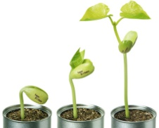

---------------------------------------------------------------------------------------------------
Goz | piquants
fête | poussent
dinosaures | partent

