Le tigre marche.

Le tigre dort.

Le tigre dort.

Le tigre marche.

Le tigre marche.

Le tigre marche.

Le tigre dort.

Le tigre dort.

Le tigre dort.

Le tigre marche.

Le tigre marche.

Le tigre marche.

Le tigre court.

Le tigre court.

Le tigre court.

Le tigre court.

Le tigre court.

Le tigre court.

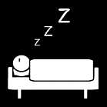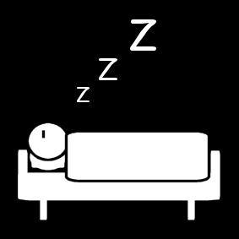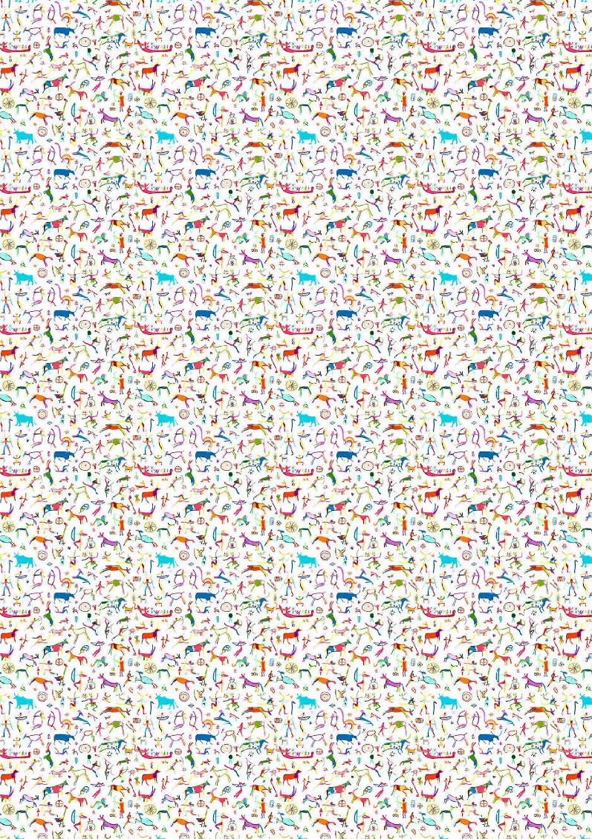  

marche

dort

dort

dort

dort

dort

dort

dort

court

|  |  |  |
| --- | --- | --- |
| Le | tigre | Le |
| dort | court | tigre |
| marche | . | . |
| Le | tigre | . |

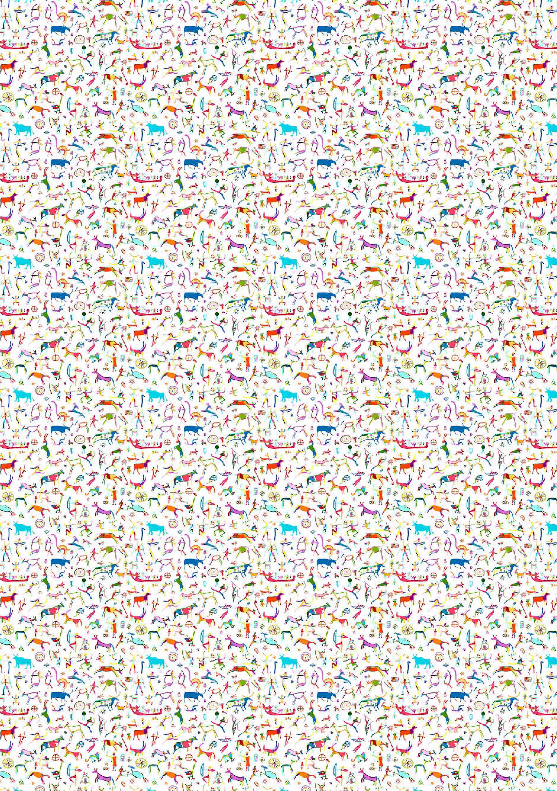

|  |  |  |  |  |  |  |
| --- | --- | --- | --- | --- | --- | --- |
| départ |  |  |  |  |  |  |

|  |  |  |  |  |  |  |
| --- | --- | --- | --- | --- | --- | --- |
|  |  |  |  |  |  | arrivée |

|  |  |  |  |  |  |  |
| --- | --- | --- | --- | --- | --- | --- |
| départ |  |  |  |  |  |  |

|  |  |  |  |  |  |  |
| --- | --- | --- | --- | --- | --- | --- |
|  |  |  |  |  |  | arrivée |