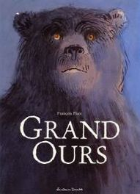
Lecture-discrimination visuelle
1
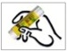
Colle les mots à la bonne place en t'aidant de ton texte.

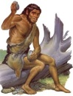

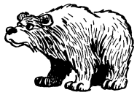

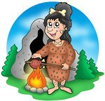

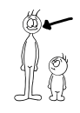

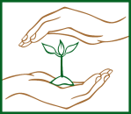

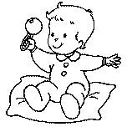

---------------------------------------------------------------------------------------------------
Nawa | grand
Wouhôn | ours
bébé | protège

Lecture-discrimination visuelle
2
Colle les mots à la bonne place en t'aidant de ton texte.

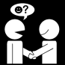

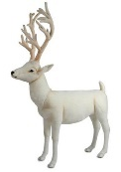

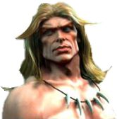

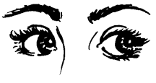

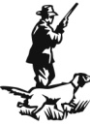

---------------------------------------------------------------------------------------------------
rencontre | Traho
regarde | yeux
Tanda | chasser

Lecture-discrimination visuelle
3
Colle les mots à la bonne place en t'aidant de ton texte.

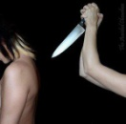

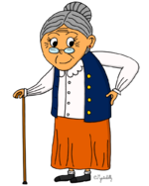

---------------------------------------------------------------------------------------------------
chasser | mamie
tuer | ours
Wouhôn | Nawa

Lecture-discrimination visuelle
4
Colle les mots à la bonne place en t'aidant de ton texte.

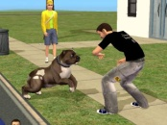

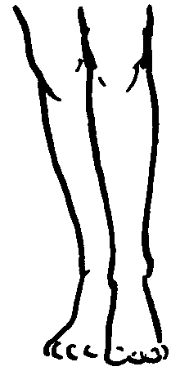

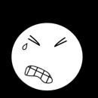

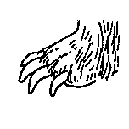

---------------------------------------------------------------------------------------------------
attaque | grand
jambe | mal
ours | griffe

Lecture-discrimination visuelle
5
Colle les mots à la bonne place en t'aidant de ton texte.

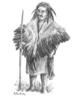

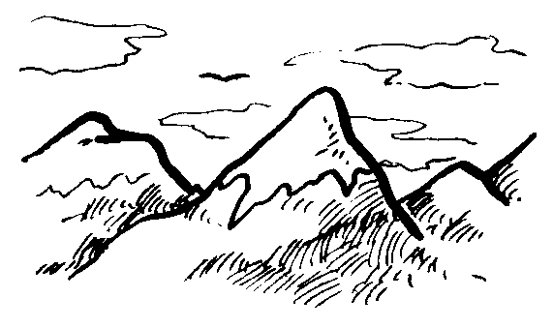

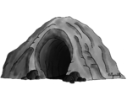

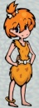

---------------------------------------------------------------------------------------------------
Frân | montagne
marchent | grotte
rencontre | Thia

Lecture-discrimination visuelle
6
Colle les mots à la bonne place en t'aidant de ton texte.

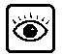

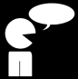

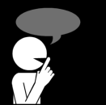

---------------------------------------------------------------------------------------------------
grand | écouter
voit | secrets
dit | ours

Lecture-discrimination visuelle
7
Colle les mots à la bonne place en t'aidant de ton texte.

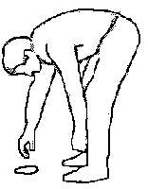

---------------------------------------------------------------------------------------------------
trouvent | Traho
Thia | dit
attaque | gagne

