

|  |  |  |  |  |  |  |  |  |  |
| --- | --- | --- | --- | --- | --- | --- | --- | --- | --- |
| d | i | p | l | o | d | o | c | u | s |
|  |  |  |  |  |  |  |  |  |  |

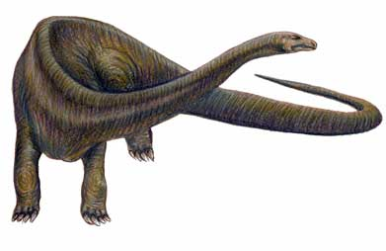

|  |  |  |  |  |  |  |  |  |  |
| --- | --- | --- | --- | --- | --- | --- | --- | --- | --- |
|  |  |  |  |  |  |  |  |  |  |



|  |  |  |  |  |  |  |  |  |  |  |  |
| --- | --- | --- | --- | --- | --- | --- | --- | --- | --- | --- | --- |
| t | y | r | a | n | n | o | s | a | u | r | e |
|  |  |  |  |  |  |  |  |  |  |  |  |

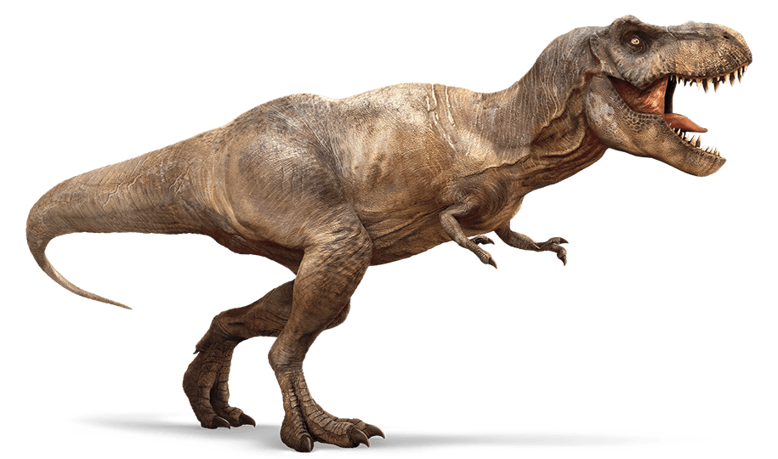

|  |  |  |  |  |  |  |  |  |  |  |  |
| --- | --- | --- | --- | --- | --- | --- | --- | --- | --- | --- | --- |
|  |  |  |  |  |  |  |  |  |  |  |  |



|  |  |  |  |  |  |  |  |  |  |  |
| --- | --- | --- | --- | --- | --- | --- | --- | --- | --- | --- |
| t | r | i | c | é | r | a | t | o | p | s |
|  |  |  |  |  |  |  |  |  |  |  |

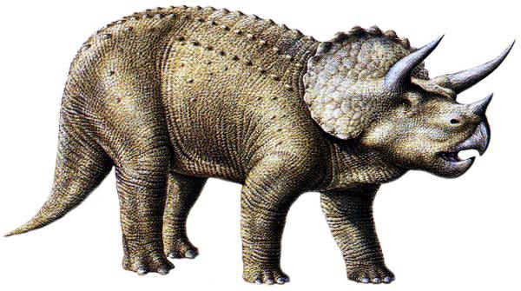

|  |  |  |  |  |  |  |  |  |  |  |
| --- | --- | --- | --- | --- | --- | --- | --- | --- | --- | --- |
|  |  |  |  |  |  |  |  |  |  |  |



|  |  |  |  |  |  |  |  |  |  |
| --- | --- | --- | --- | --- | --- | --- | --- | --- | --- |
| s | t | é | g | o | s | a | u | r | e |
|  |  |  |  |  |  |  |  |  |  |

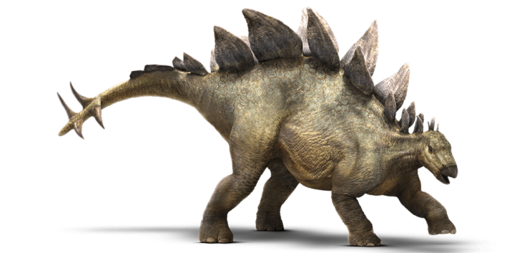

|  |  |  |  |  |  |  |  |  |  |
| --- | --- | --- | --- | --- | --- | --- | --- | --- | --- |
|  |  |  |  |  |  |  |  |  |  |



|  |  |  |  |  |  |  |  |  |  |  |
| --- | --- | --- | --- | --- | --- | --- | --- | --- | --- | --- |
| a | n | k | y | l | o | s | a | u | r | e |
|  |  |  |  |  |  |  |  |  |  |  |

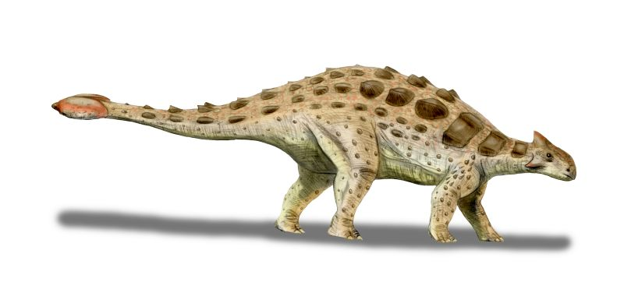

|  |  |  |  |  |  |  |  |  |  |  |
| --- | --- | --- | --- | --- | --- | --- | --- | --- | --- | --- |
|  |  |  |  |  |  |  |  |  |  |  |



|  |  |  |  |  |  |  |  |  |
| --- | --- | --- | --- | --- | --- | --- | --- | --- |
| i | g | u | a | n | o | d | o | n |
|  |  |  |  |  |  |  |  |  |

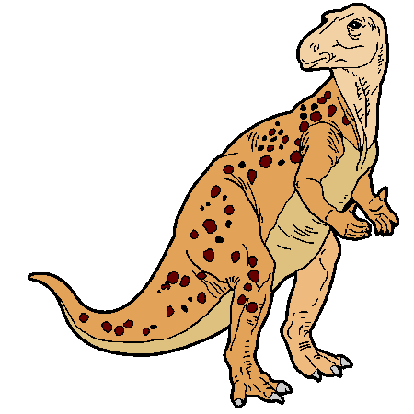

|  |  |  |  |  |  |  |  |  |
| --- | --- | --- | --- | --- | --- | --- | --- | --- |
|  |  |  |  |  |  |  |  |  |



|  |  |  |  |  |  |  |  |
| --- | --- | --- | --- | --- | --- | --- | --- |
| b | a | r | y | o | n | y | x |
|  |  |  |  |  |  |  |  |

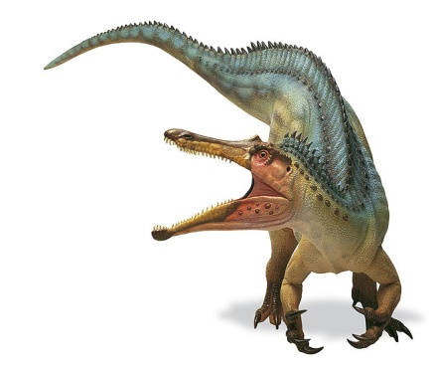

|  |  |  |  |  |  |  |  |
| --- | --- | --- | --- | --- | --- | --- | --- |
|  |  |  |  |  |  |  |  |



|  |  |  |  |  |  |  |  |  |  |  |  |
| --- | --- | --- | --- | --- | --- | --- | --- | --- | --- | --- | --- |
| v | é | l | o | c | i | r | a | p | t | o | r |
|  |  |  |  |  |  |  |  |  |  |  |  |



                        
                        
                        