|  |  |  |
| --- | --- | --- |
| Maîtrise de la langue  Lecture |  | Stade logographique |

Conceptualiser l'écrit

Tokala, l'indien-cheval

Michel Piquemal et Antoine Ronzon

Compétences travaillées :

* Connaître le nom des lettres majuscules scriptes.
* Discriminer des mots en minuscules scriptes d'autres mots.
* Retrouver un mot en minuscules scriptes à partir d'un modèle.
* Associer un mot à une image le représentant en utilisant un modèle.
* Utiliser les référents de la classe ou son texte pour identifier un mot.
* Recomposer un mot en capitales en discriminant les lettres une à une.
* Recomposer une mot écrit en capitales en faisant correspondre des lettres écrites un minuscules cursives.

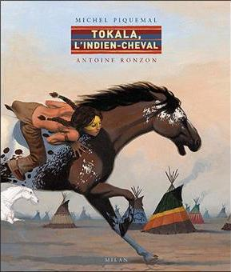Lecture-discrimination visuelle

**1**

**0 Colle.jpg**

**Colle les mots au bon endroit en t'aidant des cartes pour trouver le modèle.**



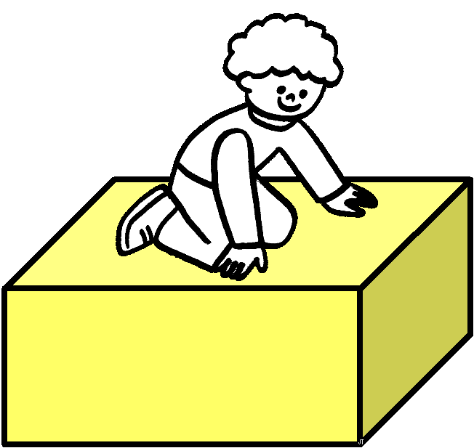

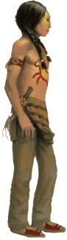

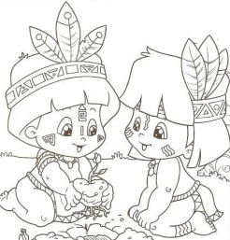

✀---------------------------------------------------------------------------------------------------

|  |  |  |
| --- | --- | --- |
| frère | Tokala | sur |
| sur | frère | Tokala |
| esprits | sur | frère |
| sur | Tokala | colline |

Lecture-discrimination visuelle

**1**

**0 Colle.jpg**

**Colle les mots à la bonne place.**

|  |  |
| --- | --- |
|  | **montagne.gif** |

|  |  |
| --- | --- |
|  | **frères.jpg** |

|  |  |
| --- | --- |
|  | **Tokala.jpg** |

|  |  |
| --- | --- |
|  | **sur.gif** |

|  |  |
| --- | --- |
|  | **indien lance.gif** |

|  |  |
| --- | --- |
|  | **esprits.jpg** |

0 Colle.jpg

0 Colle.jpg

0 Colle.jpg

0 Colle.jpg

0 Colle.jpg

0 Colle.jpg

✀---------------------------------------------------------------------------------------------------

|  |  |  |
| --- | --- | --- |
| colline | esprits | brave |
| sur | Tokala | frère |

Lecture-discrimination visuelle

**1**

**0 Colle.jpg**

**Colle les lettres pour écrire le mot.**

|  |  |  |  |  |
| --- | --- | --- | --- | --- |
| F | R | È | R | E |
| 0 Colle.jpg | 0 Colle.jpg | 0 Colle.jpg | 0 Colle.jpg | 0 Colle.jpg |

|  |  |  |  |  |  |
| --- | --- | --- | --- | --- | --- |
| T | O | K | A | L | A |
| 0 Colle.jpg | 0 Colle.jpg | 0 Colle.jpg | 0 Colle.jpg | 0 Colle.jpg | 0 Colle.jpg |

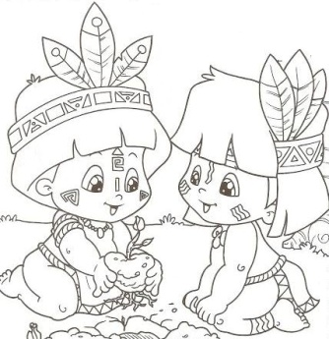

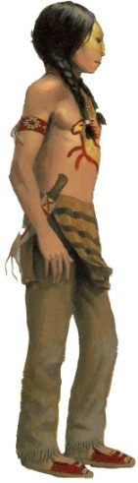

✀---------------------------------------------------------------------------------------------------------------------

|  |  |  |  |  |  |  |  |  |
| --- | --- | --- | --- | --- | --- | --- | --- | --- |
| F | E | R | M | A | L | A | Q | R |
| R | È | T | O | K | N | O | P | S |

Lecture-discrimination visuelle

**1**

**0 Colle.jpg**

**Colle les lettres pour écrire le mot.**

|  |  |  |  |  |
| --- | --- | --- | --- | --- |
| B | R | A | V | E |
| 0 Colle.jpg | 0 Colle.jpg | 0 Colle.jpg | 0 Colle.jpg | 0 Colle.jpg |

|  |  |  |  |  |  |  |
| --- | --- | --- | --- | --- | --- | --- |
| C | O | L | L | I | N | E |
| 0 Colle.jpg | 0 Colle.jpg | 0 Colle.jpg | 0 Colle.jpg | 0 Colle.jpg | 0 Colle.jpg | 0 Colle.jpg |

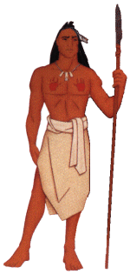

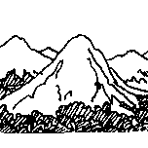

✀---------------------------------------------------------------------------------------------------------------------

|  |  |  |  |  |  |  |  |  |
| --- | --- | --- | --- | --- | --- | --- | --- | --- |
| B | O | A | L | E | E | D | G | K |
| C | R | L | V | I | N | F | H | J |

Lecture-discrimination visuelle

**1**

**0 Colle.jpg**

**Colle les lettres pour écrire le mot.**

|  |  |  |  |  |
| --- | --- | --- | --- | --- |
| f | r | è | r | e |
| 0 Colle.jpg | 0 Colle.jpg | 0 Colle.jpg | 0 Colle.jpg | 0 Colle.jpg |

|  |  |  |  |  |  |
| --- | --- | --- | --- | --- | --- |
| T | o | k | a | l | a |
| 0 Colle.jpg | 0 Colle.jpg | 0 Colle.jpg | 0 Colle.jpg | 0 Colle.jpg | 0 Colle.jpg |





✀---------------------------------------------------------------------------------------------------------------------

|  |  |  |  |  |  |  |  |  |
| --- | --- | --- | --- | --- | --- | --- | --- | --- |
| f | e | r | m | a | l | a | q | r |
| r | è | t | o | k | n | o | p | s |

Lecture-discrimination visuelle

**1**

**0 Colle.jpg**

**Colle les lettres pour écrire le mot.**

|  |  |  |  |  |
| --- | --- | --- | --- | --- |
| b | r | a | v | e |
| 0 Colle.jpg | 0 Colle.jpg | 0 Colle.jpg | 0 Colle.jpg | 0 Colle.jpg |

|  |  |  |  |  |  |  |
| --- | --- | --- | --- | --- | --- | --- |
| c | o | l | l | i | n | e |
| 0 Colle.jpg | 0 Colle.jpg | 0 Colle.jpg | 0 Colle.jpg | 0 Colle.jpg | 0 Colle.jpg | 0 Colle.jpg |





✀---------------------------------------------------------------------------------------------------------------------

|  |  |  |  |  |  |  |  |  |
| --- | --- | --- | --- | --- | --- | --- | --- | --- |
| b | o | a | l | e | e | d | g | k |
| c | r | l | v | i | n | f | h | j |

Lecture-discrimination visuelle

**2**

**0 Colle.jpg**

**Colle les mots au bon endroit en t'aidant des cartes pour trouver le modèle.**



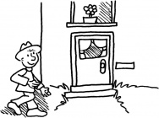

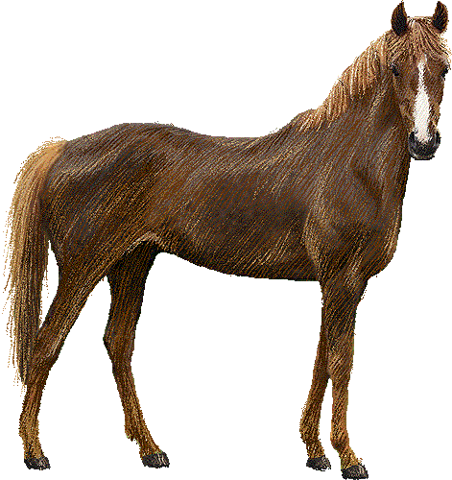

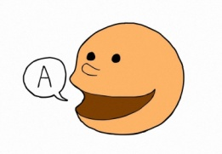

✀---------------------------------------------------------------------------------------------------

|  |  |  |
| --- | --- | --- |
| rentrer | cheval | parler |
| parler | rentrer | cheval |
| rentrer | Tokala | parler |
| cheval | cheval | rentrer |

Lecture-discrimination visuelle

**2**

**0 Colle.jpg**

**Colle les mots à la bonne place en t'aidant du texte.**

|  |  |
| --- | --- |
|  | **Tokala.jpg** |

|  |  |
| --- | --- |
|  | **tipi 2.gif** |

|  |  |
| --- | --- |
|  | **indien lance.gif** |

|  |  |
| --- | --- |
|  | **esprits.jpg** |

|  |  |
| --- | --- |
|  | **parler.jpeg** |

|  |  |
| --- | --- |
|  | **voir.gif** |

0 Colle.jpg

0 Colle.jpg

0 Colle.jpg

0 Colle.jpg

0 Colle.jpg

0 Colle.jpg

✀---------------------------------------------------------------------------------------------------

|  |  |  |
| --- | --- | --- |
| esprits | tipis | voir |
| brave | Tokala | parler |

Lecture-discrimination visuelle

**2**

**0 Colle.jpg**

**Colle les lettres pour écrire le mot.**

|  |  |  |  |  |
| --- | --- | --- | --- | --- |
| T | I | P | I | S |
| 0 Colle.jpg | 0 Colle.jpg | 0 Colle.jpg | 0 Colle.jpg | 0 Colle.jpg |

|  |  |  |  |  |  |  |
| --- | --- | --- | --- | --- | --- | --- |
| C | H | E | V | A | U | X |
| 0 Colle.jpg | 0 Colle.jpg | 0 Colle.jpg | 0 Colle.jpg | 0 Colle.jpg | 0 Colle.jpg | 0 Colle.jpg |

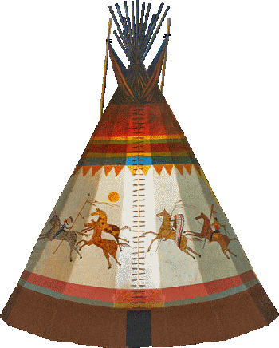



✀---------------------------------------------------------------------------------------------------------------------

|  |  |  |  |  |  |  |  |  |
| --- | --- | --- | --- | --- | --- | --- | --- | --- |
| K | T | M | N | C | H | O | U | X |
| L | I | I | P | S | E | V | A | P |

Lecture-discrimination visuelle

**2**

**0 Colle.jpg**

**Colle les lettres pour écrire le mot.**

|  |  |  |  |  |  |  |
| --- | --- | --- | --- | --- | --- | --- |
| E | S | P | R | I | T | S |
| 0 Colle.jpg | 0 Colle.jpg | 0 Colle.jpg | 0 Colle.jpg | 0 Colle.jpg | 0 Colle.jpg | 0 Colle.jpg |

|  |  |  |  |  |  |
| --- | --- | --- | --- | --- | --- |
| P | A | R | L | E | R |
| 0 Colle.jpg | 0 Colle.jpg | 0 Colle.jpg | 0 Colle.jpg | 0 Colle.jpg | 0 Colle.jpg |

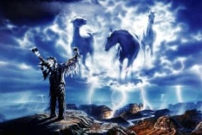

✀---------------------------------------------------------------------------------------------------------------------

|  |  |  |  |  |  |  |  |  |
| --- | --- | --- | --- | --- | --- | --- | --- | --- |
| Q | R | S | E | R | I | T | S | R |
| L | E | T | S | P | U | V | P | A |

Lecture-discrimination visuelle

**2**

**0 Colle.jpg**

**Colle les lettres pour écrire le mot.**

|  |  |  |  |  |
| --- | --- | --- | --- | --- |
| T | I | P | I | S |
| 0 Colle.jpg | 0 Colle.jpg | 0 Colle.jpg | 0 Colle.jpg | 0 Colle.jpg |

|  |  |  |  |  |  |  |
| --- | --- | --- | --- | --- | --- | --- |
| C | H | E | V | A | U | X |
| 0 Colle.jpg | 0 Colle.jpg | 0 Colle.jpg | 0 Colle.jpg | 0 Colle.jpg | 0 Colle.jpg | 0 Colle.jpg |





✀---------------------------------------------------------------------------------------------------------------------

|  |  |  |  |  |  |  |  |  |
| --- | --- | --- | --- | --- | --- | --- | --- | --- |
| k | t | m | n | c | h | o | u | x |
| l | i | i | p | s | e | v | a | p |

Lecture-discrimination visuelle

**2**

**0 Colle.jpg**

**Colle les lettres pour écrire le mot.**

|  |  |  |  |  |  |  |
| --- | --- | --- | --- | --- | --- | --- |
| E | S | P | R | I | T | S |
| 0 Colle.jpg | 0 Colle.jpg | 0 Colle.jpg | 0 Colle.jpg | 0 Colle.jpg | 0 Colle.jpg | 0 Colle.jpg |

|  |  |  |  |  |  |
| --- | --- | --- | --- | --- | --- |
| P | A | R | L | E | R |
| 0 Colle.jpg | 0 Colle.jpg | 0 Colle.jpg | 0 Colle.jpg | 0 Colle.jpg | 0 Colle.jpg |



✀---------------------------------------------------------------------------------------------------------------------

|  |  |  |  |  |  |  |  |  |
| --- | --- | --- | --- | --- | --- | --- | --- | --- |
| q | r | s | e | r | i | t | s | r |
| l | e | t | s | p | u | v | p | a |

Lecture-discrimination visuelle

**3**

**0 Colle.jpg**

**Colle les mots au bon endroit en t'aidant des cartes pour trouver le modèle.**



voir.gif

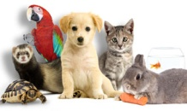

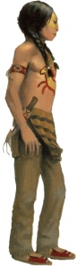

✀---------------------------------------------------------------------------------------------------

|  |  |  |
| --- | --- | --- |
| voir | animaux | Tokala |
| chercher | voir | animaux |
| Tokala | animaux | voir |
| animaux | Tokala | raconter |

Lecture-discrimination visuelle

**3**

**0 Colle.jpg**

**Colle les mots à la bonne place en t'aidant du texte.**

|  |  |
| --- | --- |
|  | **indien peau de loup.png** |

|  |  |
| --- | --- |
|  | **voir.gif** |

|  |  |
| --- | --- |
|  | **Tokala.jpg** |

|  |  |
| --- | --- |
|  | raconter.png |

|  |  |
| --- | --- |
|  | **http://www.animal-expo.com/datas/up/img/animaux_ensemble.jpg** |

|  |  |
| --- | --- |
|  | **chercher 1.jpg** |

0 Colle.jpg

0 Colle.jpg

0 Colle.jpg

0 Colle.jpg

0 Colle.jpg

0 Colle.jpg

✀---------------------------------------------------------------------------------------------------

|  |  |  |
| --- | --- | --- |
| voir | chercher | animaux |
| chaman | Tokala | raconter |

Lecture-discrimination visuelle

**3**

**0 Colle.jpg**

**Colle les lettres pour écrire le mot.**

|  |  |  |  |  |  |
| --- | --- | --- | --- | --- | --- |
| C | H | A | M | A | N |
| 0 Colle.jpg | 0 Colle.jpg | 0 Colle.jpg | 0 Colle.jpg | 0 Colle.jpg | 0 Colle.jpg |

|  |  |  |  |  |  |  |  |
| --- | --- | --- | --- | --- | --- | --- | --- |
| R | A | C | O | N | T | E | R |
| 0 Colle.jpg | 0 Colle.jpg | 0 Colle.jpg | 0 Colle.jpg | 0 Colle.jpg | 0 Colle.jpg | 0 Colle.jpg | 0 Colle.jpg |

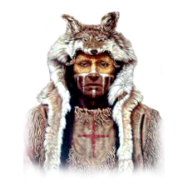



✀---------------------------------------------------------------------------------------------------------------------

|  |  |  |  |  |  |  |  |  |
| --- | --- | --- | --- | --- | --- | --- | --- | --- |
| N | R | B | G | C | M | A | A | C |
| T | E | D | F | H | A | N | R | O |

Lecture-discrimination visuelle

**3**

**0 Colle.jpg**

**Colle les lettres pour écrire le mot.**

|  |  |  |  |  |  |  |
| --- | --- | --- | --- | --- | --- | --- |
| A | N | I | M | A | U | X |
| 0 Colle.jpg | 0 Colle.jpg | 0 Colle.jpg | 0 Colle.jpg | 0 Colle.jpg | 0 Colle.jpg | 0 Colle.jpg |

|  |  |  |  |  |  |  |
| --- | --- | --- | --- | --- | --- | --- |
| C | H | E | R | C | H | E |
| 0 Colle.jpg | 0 Colle.jpg | 0 Colle.jpg | 0 Colle.jpg | 0 Colle.jpg | 0 Colle.jpg | 0 Colle.jpg |





✀---------------------------------------------------------------------------------------------------------------------

|  |  |  |  |  |  |  |  |  |
| --- | --- | --- | --- | --- | --- | --- | --- | --- |
| I | N | J | H | I | M | A | K | H |
| A | E | R | C | E | R | U | X | C |

Lecture-discrimination visuelle

**3**

**0 Colle.jpg**

**Colle les lettres pour écrire le mot.**

|  |  |  |  |  |  |
| --- | --- | --- | --- | --- | --- |
| C | H | A | M | A | N |
| 0 Colle.jpg | 0 Colle.jpg | 0 Colle.jpg | 0 Colle.jpg | 0 Colle.jpg | 0 Colle.jpg |

|  |  |  |  |  |  |  |  |
| --- | --- | --- | --- | --- | --- | --- | --- |
| R | A | C | O | N | T | E | R |
| 0 Colle.jpg | 0 Colle.jpg | 0 Colle.jpg | 0 Colle.jpg | 0 Colle.jpg | 0 Colle.jpg | 0 Colle.jpg | 0 Colle.jpg |





✀---------------------------------------------------------------------------------------------------------------------

|  |  |  |  |  |  |  |  |  |
| --- | --- | --- | --- | --- | --- | --- | --- | --- |
| n | r | b | g | c | m | a | a | c |
| t | e | d | f | h | a | n | r | o |

Lecture-discrimination visuelle

**3**

**0 Colle.jpg**

**Colle les lettres pour écrire le mot.**

|  |  |  |  |  |  |  |
| --- | --- | --- | --- | --- | --- | --- |
| A | N | I | M | A | U | X |
| 0 Colle.jpg | 0 Colle.jpg | 0 Colle.jpg | 0 Colle.jpg | 0 Colle.jpg | 0 Colle.jpg | 0 Colle.jpg |

|  |  |  |  |  |  |  |
| --- | --- | --- | --- | --- | --- | --- |
| C | H | E | R | C | H | E |
| 0 Colle.jpg | 0 Colle.jpg | 0 Colle.jpg | 0 Colle.jpg | 0 Colle.jpg | 0 Colle.jpg | 0 Colle.jpg |





✀---------------------------------------------------------------------------------------------------------------------

|  |  |  |  |  |  |  |  |  |
| --- | --- | --- | --- | --- | --- | --- | --- | --- |
| i | n | j | h | i | m | a | k | h |
| a | e | r | c | e | r | u | x | c |

Lecture-discrimination visuelle

**4**

**0 Colle.jpg**

**Colle les mots au bon endroit en t'aidant des cartes pour trouver le modèle.**



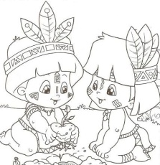



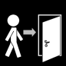

✀---------------------------------------------------------------------------------------------------

|  |  |  |
| --- | --- | --- |
| frère | colère | arriver |
| colère | arriver | frère |
| frère | Tokala | partir |
| arriver | colère | frère |

Lecture-discrimination visuelle

**4**

**0 Colle.jpg**

**Colle les mots à la bonne place en t'aidant du texte.**

|  |  |
| --- | --- |
|  | **http://historytogo.utah.gov/utah_chapters/american_indians/images/Shoshone_village__with_Chief_Washakie.jpg** |

|  |  |
| --- | --- |
|  | **arriver.png** |

|  |  |
| --- | --- |
|  | **indien fils de shoshone.gif** |

|  |  |
| --- | --- |
|  | **http://www.giifundmaresme.com/Revista_GII/Noticies/Noticies_gener_06/NOTICIA_MEXIC/images/sortir.gif** |

|  |  |
| --- | --- |
|  | colère.jpg |

|  |  |
| --- | --- |
|  | **frères.jpg** |

0 Colle.jpg

0 Colle.jpg

0 Colle.jpg

0 Colle.jpg

0 Colle.jpg

0 Colle.jpg

✀---------------------------------------------------------------------------------------------------

|  |  |  |
| --- | --- | --- |
| frère | arrive | Fils-de-Shoshone |
| colère | Shoshones | partir |

Lecture-discrimination visuelle

**4**

**0 Colle.jpg**

**Colle les lettres pour écrire le mot.**

|  |  |  |  |  |  |
| --- | --- | --- | --- | --- | --- |
| P | A | R | T | I | R |
| 0 Colle.jpg | 0 Colle.jpg | 0 Colle.jpg | 0 Colle.jpg | 0 Colle.jpg | 0 Colle.jpg |

|  |  |  |  |  |  |
| --- | --- | --- | --- | --- | --- |
| C | O | L | È | R | E |
| 0 Colle.jpg | 0 Colle.jpg | 0 Colle.jpg | 0 Colle.jpg | 0 Colle.jpg | 0 Colle.jpg |

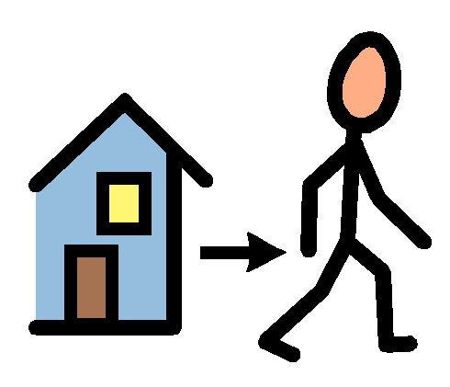



✀---------------------------------------------------------------------------------------------------------------------

|  |  |  |  |  |  |  |  |  |
| --- | --- | --- | --- | --- | --- | --- | --- | --- |
| P | É | Z | R | C | O | L | W | X |
| A | R | T | I | È | À | R | E | Y |

Lecture-discrimination visuelle

**4**

**0 Colle.jpg**

**Colle les lettres pour écrire le mot.**

|  |  |  |  |  |  |
| --- | --- | --- | --- | --- | --- |
| T | O | K | A | L | A |
| 0 Colle.jpg | 0 Colle.jpg | 0 Colle.jpg | 0 Colle.jpg | 0 Colle.jpg | 0 Colle.jpg |

|  |  |  |  |  |  |
| --- | --- | --- | --- | --- | --- |
| A | R | R | I | V | E |
| 0 Colle.jpg | 0 Colle.jpg | 0 Colle.jpg | 0 Colle.jpg | 0 Colle.jpg | 0 Colle.jpg |





✀---------------------------------------------------------------------------------------------------------------------

|  |  |  |  |  |  |  |  |  |
| --- | --- | --- | --- | --- | --- | --- | --- | --- |
| T | O | K | F | A | R | G | E | B |
| D | E | A | L | A | R | I | V | C |

Lecture-discrimination visuelle

**4**

**0 Colle.jpg**

**Colle les lettres pour écrire le mot.**

|  |  |  |  |  |  |
| --- | --- | --- | --- | --- | --- |
| P | A | R | T | I | R |
| 0 Colle.jpg | 0 Colle.jpg | 0 Colle.jpg | 0 Colle.jpg | 0 Colle.jpg | 0 Colle.jpg |

|  |  |  |  |  |  |
| --- | --- | --- | --- | --- | --- |
| C | O | L | È | R | E |
| 0 Colle.jpg | 0 Colle.jpg | 0 Colle.jpg | 0 Colle.jpg | 0 Colle.jpg | 0 Colle.jpg |





✀---------------------------------------------------------------------------------------------------------------------

|  |  |  |  |  |  |  |  |  |
| --- | --- | --- | --- | --- | --- | --- | --- | --- |
| p | é | z | r | c | o | l | w | x |
| a | r | t | i | è | à | r | e | y |

Lecture-discrimination visuelle

**4**

**0 Colle.jpg**

**Colle les lettres pour écrire le mot.**

|  |  |  |  |  |  |
| --- | --- | --- | --- | --- | --- |
| T | O | K | A | L | A |
| 0 Colle.jpg | 0 Colle.jpg | 0 Colle.jpg | 0 Colle.jpg | 0 Colle.jpg | 0 Colle.jpg |

|  |  |  |  |  |  |
| --- | --- | --- | --- | --- | --- |
| A | R | R | I | V | E |
| 0 Colle.jpg | 0 Colle.jpg | 0 Colle.jpg | 0 Colle.jpg | 0 Colle.jpg | 0 Colle.jpg |





✀---------------------------------------------------------------------------------------------------------------------

|  |  |  |  |  |  |  |  |  |
| --- | --- | --- | --- | --- | --- | --- | --- | --- |
| t | o | k | f | a | r | g | e | b |
| d | e | a | l | a | r | i | v | c |

Lecture-discrimination visuelle

**5**

**0 Colle.jpg**

**Colle les mots au bon endroit en t'aidant des cartes pour trouver le modèle.**



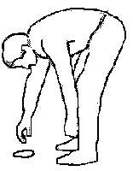

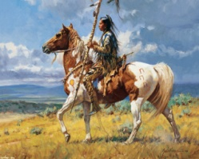

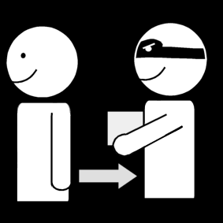

✀---------------------------------------------------------------------------------------------------

|  |  |  |
| --- | --- | --- |
| trouver | voler | indien |
| trouver | indien | Tokala |
| indien | trouver | voler |
| voler | indien | trouver |

Lecture-discrimination visuelle

**5**

**0 Colle.jpg**

**Colle les mots à la bonne place en t'aidant du texte.**

|  |  |
| --- | --- |
|  | **http://www.giifundmaresme.com/Revista_GII/Noticies/Noticies_gener_06/NOTICIA_MEXIC/images/sortir.gif** |

|  |  |
| --- | --- |
|  | **indien fils de shoshone.gif** |

|  |  |
| --- | --- |
|  | **trouver.gif** |

|  |  |
| --- | --- |
|  | **cheval couleur.gif** |

|  |  |
| --- | --- |
|  | **voler 2.png** |

|  |  |
| --- | --- |
|  | **Tokala.jpg** |

0 Colle.jpg

0 Colle.jpg

0 Colle.jpg

0 Colle.jpg

0 Colle.jpg

0 Colle.jpg

✀---------------------------------------------------------------------------------------------------

|  |  |  |
| --- | --- | --- |
| Tokala | trouvent | part |
| vole | chevaux | Fils-de-Shoshone |

Lecture-discrimination visuelle

**5**

**0 Colle.jpg**

**Colle les lettres pour écrire le mot.**

|  |  |  |  |  |  |
| --- | --- | --- | --- | --- | --- |
| I | N | D | I | E | N |
| 0 Colle.jpg | 0 Colle.jpg | 0 Colle.jpg | 0 Colle.jpg | 0 Colle.jpg | 0 Colle.jpg |

|  |  |  |  |  |  |
| --- | --- | --- | --- | --- | --- |
| C | H | E | V | A | L |
| 0 Colle.jpg | 0 Colle.jpg | 0 Colle.jpg | 0 Colle.jpg | 0 Colle.jpg | 0 Colle.jpg |





✀---------------------------------------------------------------------------------------------------------------------

|  |  |  |  |  |  |  |  |  |
| --- | --- | --- | --- | --- | --- | --- | --- | --- |
| V | I | C | F | G | L | É | È | B |
| A | N | D | I | E | N | H | E | C |

Lecture-discrimination visuelle

**5**

**0 Colle.jpg**

**Colle les lettres pour écrire le mot.**

|  |  |  |  |  |
| --- | --- | --- | --- | --- |
| V | O | L | E | R |
| 0 Colle.jpg | 0 Colle.jpg | 0 Colle.jpg | 0 Colle.jpg | 0 Colle.jpg |

|  |  |  |  |  |  |  |
| --- | --- | --- | --- | --- | --- | --- |
| T | R | O | U | V | E | R |
| 0 Colle.jpg | 0 Colle.jpg | 0 Colle.jpg | 0 Colle.jpg | 0 Colle.jpg | 0 Colle.jpg | 0 Colle.jpg |





✀---------------------------------------------------------------------------------------------------------------------

|  |  |  |  |  |  |  |  |  |
| --- | --- | --- | --- | --- | --- | --- | --- | --- |
| T | R | I | V | E | R | M | E | R |
| H | O | U | J | K | V | O | L | N |

Lecture-discrimination visuelle

**5**

**0 Colle.jpg**

**Colle les lettres pour écrire le mot.**

|  |  |  |  |  |  |
| --- | --- | --- | --- | --- | --- |
| I | N | D | I | E | N |
| 0 Colle.jpg | 0 Colle.jpg | 0 Colle.jpg | 0 Colle.jpg | 0 Colle.jpg | 0 Colle.jpg |

|  |  |  |  |  |  |
| --- | --- | --- | --- | --- | --- |
| C | H | E | V | A | L |
| 0 Colle.jpg | 0 Colle.jpg | 0 Colle.jpg | 0 Colle.jpg | 0 Colle.jpg | 0 Colle.jpg |





✀---------------------------------------------------------------------------------------------------------------------

|  |  |  |  |  |  |  |  |  |
| --- | --- | --- | --- | --- | --- | --- | --- | --- |
| v | i | c | f | g | l | é | è | b |
| a | n | d | i | e | n | h | e | c |

Lecture-discrimination visuelle

**5**

**0 Colle.jpg**

**Colle les lettres pour écrire le mot.**

|  |  |  |  |  |
| --- | --- | --- | --- | --- |
| V | O | L | E | R |
| 0 Colle.jpg | 0 Colle.jpg | 0 Colle.jpg | 0 Colle.jpg | 0 Colle.jpg |

|  |  |  |  |  |  |  |
| --- | --- | --- | --- | --- | --- | --- |
| T | R | O | U | V | E | R |
| 0 Colle.jpg | 0 Colle.jpg | 0 Colle.jpg | 0 Colle.jpg | 0 Colle.jpg | 0 Colle.jpg | 0 Colle.jpg |





✀---------------------------------------------------------------------------------------------------------------------

|  |  |  |  |  |  |  |  |  |
| --- | --- | --- | --- | --- | --- | --- | --- | --- |
| t | r | i | v | e | r | m | e | r |
| h | o | u | j | k | v | o | l | n |

Lecture-discrimination visuelle

**6**

**0 Colle.jpg**

**Colle les mots au bon endroit en t'aidant des cartes pour trouver le modèle.**



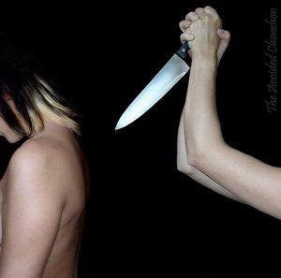

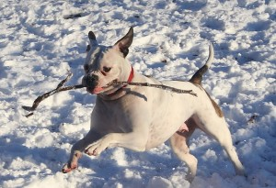

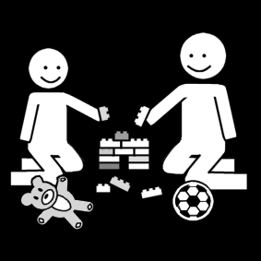

✀---------------------------------------------------------------------------------------------------

|  |  |  |
| --- | --- | --- |
| ramener | tuer | indien |
| partager | tuer | partager |
| Tokala | ramener | tuer |
| tuer | partager | ramener |

Lecture-discrimination visuelle

**6**

**0 Colle.jpg**

**Colle les mots à la bonne place en t'aidant du texte.**

|  |  |
| --- | --- |
|  | **indien.jpg** |

|  |  |
| --- | --- |
|  | **tuer.jpg** |

|  |  |
| --- | --- |
|  | **frères.jpg** |

|  |  |
| --- | --- |
|  | **http://historytogo.utah.gov/utah_chapters/american_indians/images/Shoshone_village__with_Chief_Washakie.jpg** |

|  |  |
| --- | --- |
|  | **cheval couleur.gif** |

|  |  |
| --- | --- |
|  | **indien lance.gif** |

0 Colle.jpg

0 Colle.jpg

0 Colle.jpg

0 Colle.jpg

0 Colle.jpg

0 Colle.jpg

✀---------------------------------------------------------------------------------------------------

|  |  |  |
| --- | --- | --- |
| indien | chevaux | braves |
| tuer | frère | Shoshones |

Lecture-discrimination visuelle

**6**

**0 Colle.jpg**

**Colle les lettres pour écrire le mot.**

|  |  |  |  |  |
| --- | --- | --- | --- | --- |
| B | R | A | V | E |
| 0 Colle.jpg | 0 Colle.jpg | 0 Colle.jpg | 0 Colle.jpg | 0 Colle.jpg |

|  |  |  |  |  |  |  |
| --- | --- | --- | --- | --- | --- | --- |
| R | A | M | E | N | E | R |
| 0 Colle.jpg | 0 Colle.jpg | 0 Colle.jpg | 0 Colle.jpg | 0 Colle.jpg | 0 Colle.jpg | 0 Colle.jpg |





✀---------------------------------------------------------------------------------------------------------------------

|  |  |  |  |  |  |  |  |  |
| --- | --- | --- | --- | --- | --- | --- | --- | --- |
| B | V | E | M | E | R | O | R | S |
| R | A | R | A | N | E | P | Q | T |

Lecture-discrimination visuelle

**6**

**0 Colle.jpg**

**Colle les lettres pour écrire le mot.**

|  |  |  |  |  |
| --- | --- | --- | --- | --- |
| T | R | O | I | S |
| 0 Colle.jpg | 0 Colle.jpg | 0 Colle.jpg | 0 Colle.jpg | 0 Colle.jpg |

|  |  |  |  |  |  |  |  |
| --- | --- | --- | --- | --- | --- | --- | --- |
| P | A | R | T | A | G | E | R |
| 0 Colle.jpg | 0 Colle.jpg | 0 Colle.jpg | 0 Colle.jpg | 0 Colle.jpg | 0 Colle.jpg | 0 Colle.jpg | 0 Colle.jpg |

3



✀---------------------------------------------------------------------------------------------------------------------

|  |  |  |  |  |  |  |  |  |
| --- | --- | --- | --- | --- | --- | --- | --- | --- |
| T | I | S | R | T | G | U | V | Z |
| R | O | P | A | A | E | R | W | X |

Lecture-discrimination visuelle

**6**

**0 Colle.jpg**

**Colle les lettres pour écrire le mot.**

|  |  |  |  |  |
| --- | --- | --- | --- | --- |
| B | R | A | V | E |
| 0 Colle.jpg | 0 Colle.jpg | 0 Colle.jpg | 0 Colle.jpg | 0 Colle.jpg |

|  |  |  |  |  |  |  |
| --- | --- | --- | --- | --- | --- | --- |
| R | A | M | E | N | E | R |
| 0 Colle.jpg | 0 Colle.jpg | 0 Colle.jpg | 0 Colle.jpg | 0 Colle.jpg | 0 Colle.jpg | 0 Colle.jpg |





✀---------------------------------------------------------------------------------------------------------------------

|  |  |  |  |  |  |  |  |  |
| --- | --- | --- | --- | --- | --- | --- | --- | --- |
| b | v | e | m | e | r | o | r | s |
| r | a | r | a | n | e | p | q | t |

Lecture-discrimination visuelle

**6**

**0 Colle.jpg**

**Colle les lettres pour écrire le mot.**

|  |  |  |  |  |
| --- | --- | --- | --- | --- |
| T | R | O | I | S |
| 0 Colle.jpg | 0 Colle.jpg | 0 Colle.jpg | 0 Colle.jpg | 0 Colle.jpg |

|  |  |  |  |  |  |  |  |
| --- | --- | --- | --- | --- | --- | --- | --- |
| P | A | R | T | A | G | E | R |
| 0 Colle.jpg | 0 Colle.jpg | 0 Colle.jpg | 0 Colle.jpg | 0 Colle.jpg | 0 Colle.jpg | 0 Colle.jpg | 0 Colle.jpg |

3



✀---------------------------------------------------------------------------------------------------------------------

|  |  |  |  |  |  |  |  |  |
| --- | --- | --- | --- | --- | --- | --- | --- | --- |
| t | i | s | r | t | g | u | v | z |
| r | o | p | a | a | e | r | w | x |

|  |  |  |  |  |
| --- | --- | --- | --- | --- |
| Tokala.jpg | sur.gif | montagne.gif | indien lance.gif | frères.jpg |
| Tokala | sur | colline | brave | frère |

|  |  |  |  |  |
| --- | --- | --- | --- | --- |
| parler.jpeg | esprits.jpg | rentrer.jpg | tipi 2.gif | voir.gif |
| parler | esprits | rentrer | tipis | voir |

|  |  |  |  |  |
| --- | --- | --- | --- | --- |
| cheval couleur.gif | indien peau de loup.png | raconter.png | http://www.animal-expo.com/datas/up/img/animaux_ensemble.jpg | chercher 1.jpg |
| cheval | chaman | raconter | animaux | chercher |

|  |  |  |  |  |
| --- | --- | --- | --- | --- |
| http://www.giifundmaresme.com/Revista_GII/Noticies/Noticies_gener_06/NOTICIA_MEXIC/images/sortir.gif | colère.jpg | indien fils de shoshone.gif | arriver.png | http://historytogo.utah.gov/utah_chapters/american_indians/images/Shoshone_village__with_Chief_Washakie.jpg |
| partir | colère | Fils-de-Shoshone | arriver | Shoshones |

|  |  |  |  |  |
| --- | --- | --- | --- | --- |
| trouver.gif | voler 2.png | indien.jpg | tuer.jpg | partager.png |
| trouver | voler | indien | tuer | partager |

|  |  |  |  |  |
| --- | --- | --- | --- | --- |
| 3 | http://www.petsitting.fr/wp-content/uploads/2014/02/chien-qui-rapporte-300x205.jpg |  |  |  |
| trois | ramener |  |  |  |