|  |  |  |
| --- | --- | --- |
| Maîtrise de la langue  Lecture |  | Stade logographique |

Conceptualiser l'écrit

Plume-Rouge

Michel Piquemal et Marcelino Truong

Compétences travaillées :

* Connaître le nom des lettres majuscules scriptes.
* Discriminer des mots en minuscules scriptes d'autres mots.
* Retrouver un mot en minuscules scriptes à partir d'un modèle.
* Associer un mot à une image le représentant en utilisant un modèle.

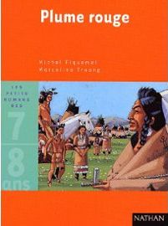Lecture-discrimination visuelle

**1**

**0 Colle.jpg**

**Colle les lettres pour écrire le mot.**

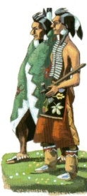 CROWS

|  |  |  |  |  |
| --- | --- | --- | --- | --- |
| 0 Colle.jpg | 0 Colle.jpg | 0 Colle.jpg | 0 Colle.jpg | 0 Colle.jpg |

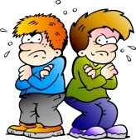 ENNEMIS

|  |  |  |  |  |  |  |
| --- | --- | --- | --- | --- | --- | --- |
| 0 Colle.jpg | 0 Colle.jpg | 0 Colle.jpg | 0 Colle.jpg | 0 Colle.jpg | 0 Colle.jpg | 0 Colle.jpg |

✀---------------------------------------------------------------------------------------------------------------------

|  |  |  |  |  |  |  |  |  |
| --- | --- | --- | --- | --- | --- | --- | --- | --- |
| E | B | O | C | W | F | C | J | K |
| N | A | E | D | M | G | H | R | S |

Lecture-discrimination visuelle

**1**

**0 Colle.jpg**

**Colle les mots au bon endroit en t'aidant des cartes pour trouver le modèle.**



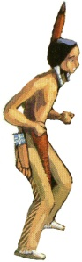

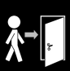

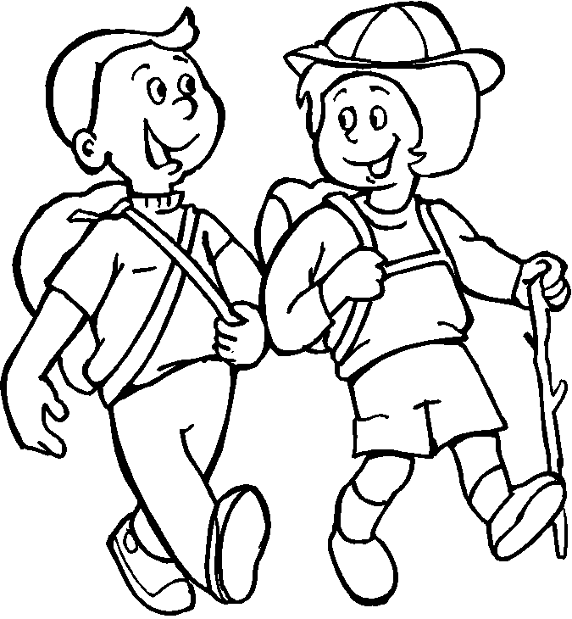

✀---------------------------------------------------------------------------------------------------

|  |  |  |
| --- | --- | --- |
| Plume-Rouge | promène | arrive |
| Crows | Plume-Rouge | ennemis |
| arrive | promène | fête |
| promène | arrive | Plume-Rouge |

Lecture-discrimination visuelle

**1**

**0 Colle.jpg**

**Colle les images à la bonne place.**

|  |  |
| --- | --- |
| **fête** |  |

|  |  |
| --- | --- |
| **Plume-Rouge** |  |

|  |  |
| --- | --- |
| **Crows** |  |

|  |  |
| --- | --- |
| **ennemis** |  |

|  |  |
| --- | --- |
| **promène** |  |

|  |  |
| --- | --- |
| **Plume-Rouge** |  |

0 Colle.jpg

0 Colle.jpg

0 Colle.jpg

0 Colle.jpg

0 Colle.jpg

0 Colle.jpg

✀---------------------------------------------------------------------------------------------------

|  |  |  |  |  |
| --- | --- | --- | --- | --- |
| Plume Rouge.jpg | Plume-Rouge002b.jpg | arriver.png | ennemis.jpg | bottes.gif |
| http://www.coloriage-dessin.com/coloriage_img/coloriage-scout-1230291903.gif | Dessin fête de carnaval a colorier | indienne fillette oiseua.jpg | tipi 3.gif | Plume Rouge.jpg |

Lecture-discrimination visuelle

**1**

**0 Colle.jpg**

**Colle les mots à la bonne place.**

|  |  |
| --- | --- |
|  | **Plume Rouge.jpg** |

|  |  |
| --- | --- |
|  | **Plume-Rouge002b.jpg** |

|  |  |
| --- | --- |
|  | **arriver.png** |

|  |  |
| --- | --- |
|  | **ennemis.jpg** |

|  |  |
| --- | --- |
|  | **http://www.coloriage-dessin.com/coloriage_img/coloriage-scout-1230291903.gif** |

|  |  |
| --- | --- |
|  | **Dessin fête de carnaval a colorier** |

0 Colle.jpg

0 Colle.jpg

0 Colle.jpg

0 Colle.jpg

0 Colle.jpg

0 Colle.jpg

✀---------------------------------------------------------------------------------------------------

|  |  |  |
| --- | --- | --- |
| arrive | Plume-Rouge | chez |
| fête | ennemis | promener |
| Crows | est | va |

Lecture-discrimination visuelle

**3**

**0 Colle.jpg**

**Colle les lettres pour écrire le mot.**

|  |  |  |  |
| --- | --- | --- | --- |
| T | I | P | I |
| 0 Colle.jpg | 0 Colle.jpg | 0 Colle.jpg | 0 Colle.jpg |

|  |  |  |  |  |
| --- | --- | --- | --- | --- |
| M | A | M | A | N |
| 0 Colle.jpg | 0 Colle.jpg | 0 Colle.jpg | 0 Colle.jpg | 0 Colle.jpg |

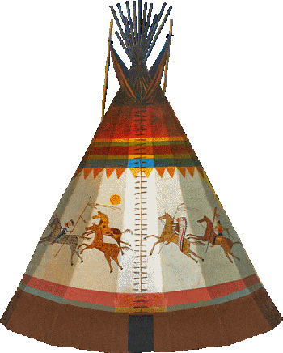

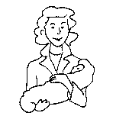

✀---------------------------------------------------------------------------------------------------------------------

|  |  |  |  |  |  |  |  |  |
| --- | --- | --- | --- | --- | --- | --- | --- | --- |
| M | C | D | T | F | G | P | K | A |
| B | A | E | M | I | H | J | N | I |

Lecture-discrimination visuelle

**3**

**0 Colle.jpg**

**Colle les lettres pour écrire le mot.**

|  |  |  |  |
| --- | --- | --- | --- |
| D | A | N | S |
| 0 Colle.jpg | 0 Colle.jpg | 0 Colle.jpg | 0 Colle.jpg |

|  |  |  |  |  |  |  |  |
| --- | --- | --- | --- | --- | --- | --- | --- |
| C | E | I | N | T | U | R | E |
| 0 Colle.jpg | 0 Colle.jpg | 0 Colle.jpg | 0 Colle.jpg | 0 Colle.jpg | 0 Colle.jpg | 0 Colle.jpg | 0 Colle.jpg |

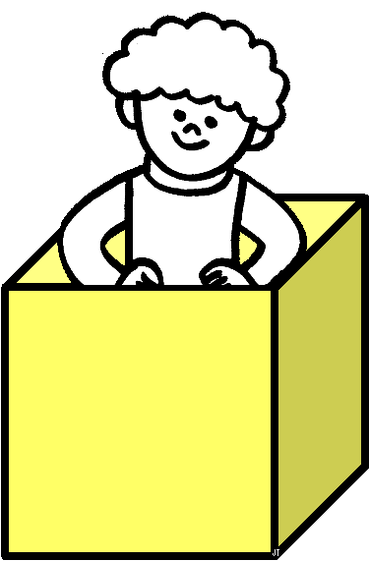

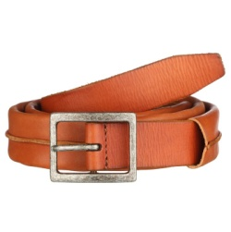

✀---------------------------------------------------------------------------------------------------------------------

|  |  |  |  |  |  |  |  |  |
| --- | --- | --- | --- | --- | --- | --- | --- | --- |
| E | D | I | N | A | E | O | P | V |
| C | L | M | T | U | R | N | Q | S |

Lecture-discrimination visuelle

**4**

**0 Colle.jpg**

**Colle les lettres pour écrire le mot.**

|  |  |  |  |  |
| --- | --- | --- | --- | --- |
| F | L | E | U | R |
| 0 Colle.jpg | 0 Colle.jpg | 0 Colle.jpg | 0 Colle.jpg | 0 Colle.jpg |

|  |  |  |  |  |  |
| --- | --- | --- | --- | --- | --- |
| C | H | E | V | A | L |
| 0 Colle.jpg | 0 Colle.jpg | 0 Colle.jpg | 0 Colle.jpg | 0 Colle.jpg | 0 Colle.jpg |

4



4

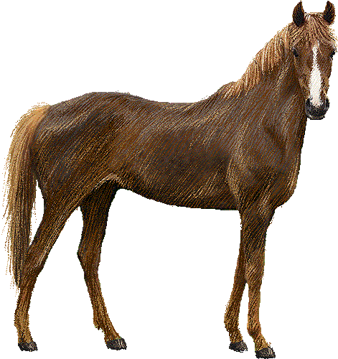

✀---------------------------------------------------------------------------------------------------------------------

|  |  |  |  |  |  |  |  |  |
| --- | --- | --- | --- | --- | --- | --- | --- | --- |
| F | L | D | R | C | G | I | A | L |
| B | E | U | F | H | E | V | J | K |

Lecture-discrimination visuelle

**4**

**0 Colle.jpg**

**Colle les lettres pour écrire le mot.**

|  |  |  |  |  |  |
| --- | --- | --- | --- | --- | --- |
| D | E | B | O | U | T |
| 0 Colle.jpg | 0 Colle.jpg | 0 Colle.jpg | 0 Colle.jpg | 0 Colle.jpg | 0 Colle.jpg |

|  |  |  |  |  |  |  |
| --- | --- | --- | --- | --- | --- | --- |
| L | U | C | I | O | L | E |
| 0 Colle.jpg | 0 Colle.jpg | 0 Colle.jpg | 0 Colle.jpg | 0 Colle.jpg | 0 Colle.jpg | 0 Colle.jpg |

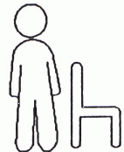

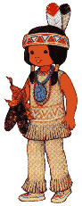

✀---------------------------------------------------------------------------------------------------------------------

|  |  |  |  |  |  |  |  |  |
| --- | --- | --- | --- | --- | --- | --- | --- | --- |
| D | M | U | T | L | U | Q | O | L |
| E | B | O | N | P | C | I | R | E |

Lecture-discrimination visuelle

**5**

**0 Colle.jpg**

**Colle les lettres pour écrire le mot.**

|  |  |  |  |  |  |
| --- | --- | --- | --- | --- | --- |
| P | A | R | L | E | R |
| 0 Colle.jpg | 0 Colle.jpg | 0 Colle.jpg | 0 Colle.jpg | 0 Colle.jpg | 0 Colle.jpg |

|  |  |  |  |  |  |  |
| --- | --- | --- | --- | --- | --- | --- |
| E | S | P | R | I | T | S |
| 0 Colle.jpg | 0 Colle.jpg | 0 Colle.jpg | 0 Colle.jpg | 0 Colle.jpg | 0 Colle.jpg | 0 Colle.jpg |

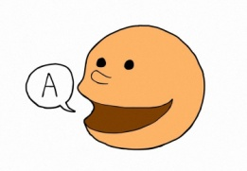

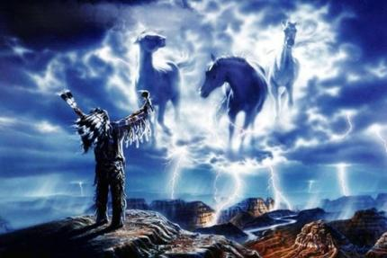

✀---------------------------------------------------------------------------------------------------------------------

|  |  |  |  |  |  |  |  |  |
| --- | --- | --- | --- | --- | --- | --- | --- | --- |
| P | E | S | E | R | T | S | Y | V |
| A | R | L | P | R | I | U | X | W |

Lecture-discrimination visuelle

**5**

**0 Colle.jpg**

**Colle les lettres pour écrire le mot.**

|  |  |  |
| --- | --- | --- |
| S | A | C |
| 0 Colle.jpg | 0 Colle.jpg | 0 Colle.jpg |

|  |  |  |  |  |
| --- | --- | --- | --- | --- |
| V | O | L | E | R |
| 0 Colle.jpg | 0 Colle.jpg | 0 Colle.jpg | 0 Colle.jpg | 0 Colle.jpg |

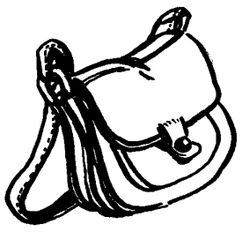

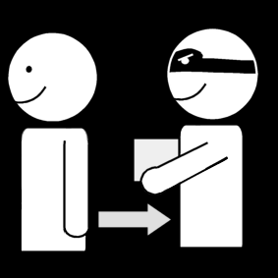

✀---------------------------------------------------------------------------------------------------------------------

|  |  |  |  |  |  |  |  |  |
| --- | --- | --- | --- | --- | --- | --- | --- | --- |
| V | O | N | S | A | D | F | I | J |
| M | L | E | R | C | B | G | H | K |

|  |  |  |  |  |
| --- | --- | --- | --- | --- |
| Plume Rouge.jpg | Plume-Rouge002b.jpg | arriver.png | ennemis.jpg | http://www.coloriage-dessin.com/coloriage_img/coloriage-scout-1230291903.gif |
| Plume-Rouge | Crows | arriver | ennemis | promener |

|  |  |  |  |  |
| --- | --- | --- | --- | --- |
| Dessin fête de carnaval a colorier | indienne.gif | voir.gif | Parler 1.png | partager.png |
| fête | Luciole | voir | dire | jouer |

|  |  |  |  |  |
| --- | --- | --- | --- | --- |
| Loup Renard.jpg | colère.jpg | emmener.png | dans.gif | tipi 2.gif |
| Loup-Renard | colère | emmener | dans | tipi |

|  |  |  |  |  |
| --- | --- | --- | --- | --- |
| maman.gif | broder.jpg | montrer.jpg | ceinture 1.jpg | cheval couleur.gif |
| maman | broder | montrer | ceinture | cheval |

|  |  |  |  |  |
| --- | --- | --- | --- | --- |
| ramasser.jpg | flower yellow color.png | debout.gif | voler 2.png | SAC.BMP |
| ramasser | fleur | debout | voler | sac |

|  |  |  |  |  |
| --- | --- | --- | --- | --- |
| esprits.jpg | parler.jpeg | CACHER.gif | http://www.nouveauxsports.fr/wp-content/uploads/2014/04/lacrosse-alain-polin-nouveaux-sports.jpg | donner.png |
| esprits | parler | cacher | crosse | donner |